Fundamentals of Algorithmic Problem Solving
OR
Briefly discuss a sequence of steps one typically goes through in designing and analyzing an algorithm
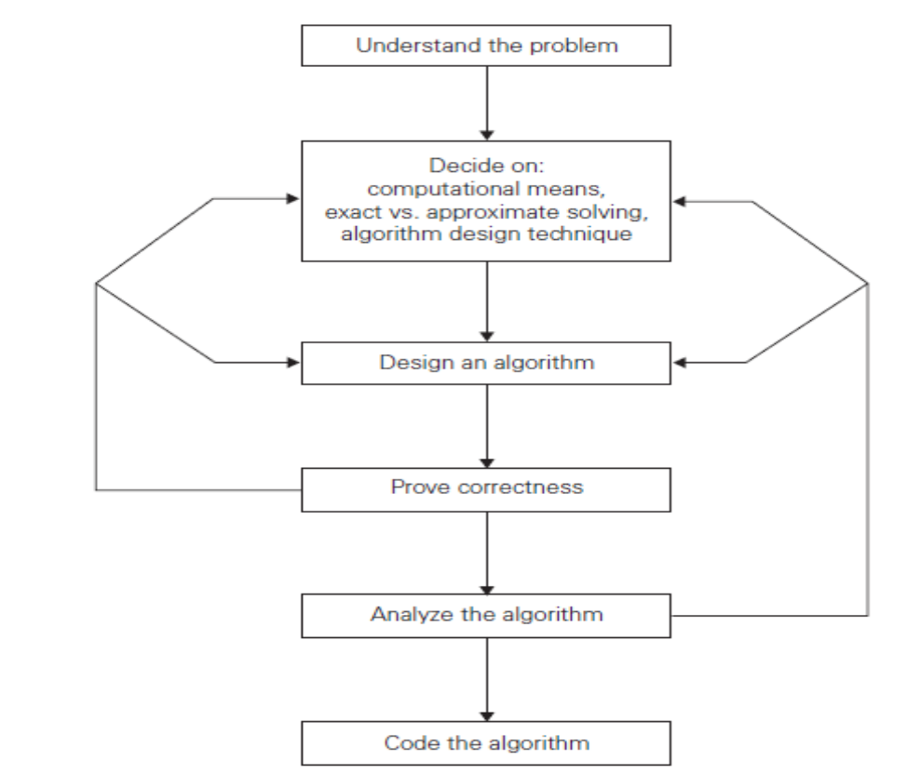

Understanding the Problem
- An input to an algorithm specifies an instance of the problem the algorithm solves. It is very important to specify exactly the set of instances the algorithm needs to handle.
- Algorithm may work correctly for a majority of inputs but crash on some “boundary” value.
- A correct algorithm is not one that works most of the time, but one that works correctly for all legitimate inputs.
Ascertaining the Capabilities of the Computational Device
- von Neumann machine is based on random-access machine (RAM) model. Its central assumption is that instructions are executed one after another, one operation at a time. Accordingly, algorithms designed to be executed on such machines are called sequential algorithms.
- Algorithms which can execute operations concurrently are called as parallel algorithms.
- Problems, those are very complex by their nature, or have to process huge volumes of data, or deal with applications where the time is critical. In such cases, it is imperative to be aware of the speed and memory available on a particular computer system.
Choosing between Exact and Approximate Problem Solving
- Problems can be solved either exactly or approximately.
- An algorithm that solves the problem exactly is called an exact algorithm.
- An algorithm that solves the problem approximately is called an approximation algorithm.
- Why would one opt for an approximation algorithm?
- First, there are important problems that simply cannot be solved exactly for most of their instances; examples include extracting square roots, solving nonlinear equations, and evaluating definite integrals. Second, available algorithms for solving a problem exactly can be unacceptably slow because of the problem’s intrinsic complexity.
- Third, an approximation algorithm can be a part of a more sophisticated algorithm that solves a problem exactly.
Algorithm Design Techniques
- An algorithm design technique (or “strategy” or “paradigm”) is a general approach to solving problems algorithmically that is applicable to a variety of problems from different areas of computing.
- First, they provide guidance for designing algorithms for new problems, i.e., problems for which there is no known satisfactory algorithm.
- Second, algorithms are the cornerstone of computer science. Algorithm design techniques make it possible to classify algorithms according to an underlying design idea;
Designing an Algorithm and Data Structures
- Algorithms+ Data Structures = Programs
Methods of Specifying an Algorithm
- Algorithm
- Pseudocode
- Flowchart
Proving an Algorithm’s Correctness
- Once an algorithm has been specified, then algorithm has to be proved for its correctness. It is necessary to prove that the algorithm yields a required result for every legitimate input in a finite amount of time.
- For example, the correctness of Euclid’s algorithm for computing the greatest common divisor stems from the correctness of the equality gcd(m, n) = gcd(n, m mod n)
- For some algorithms, a proof of correctness is quite easy; for others, it can be quite complex.
- A common technique for proving correctness is to use mathematical induction because an algorithm’s iterations provide a natural sequence of steps needed for such proofs.
- Tracing the algorithm’s performance for a few specific inputs can be a very worthwhile activity. It cannot prove the algorithm’s correctness conclusively. But in order to show that an algorithm is incorrect, just one instance of its input is alone needed for which the algorithm fails.
- For an approximation algorithm, it is enough to show that the error produced by the algorithm does not exceed a predefined limit.
Analyzing an Algorithm
- Time efficiency, indicates how fast the algorithm runs.
- Space efficiency indicates how much extra memory it uses
- Another desirable characteristic of an algorithm is simplicity. Simpler algorithms are easier to understand and easier to program; consequently, the resulting programs usually contain fewer bugs. Sometimes simpler algorithms are also more efficient than more complicated alternatives. Unfortunately, it is not always true
- Yet another desirable characteristic of an algorithm is generality. There are, in fact, two issues here: generality of the problem the algorithm solves and the set of inputs it accepts.
- First issue is, for a problem it is sometimes easier to design an algorithm posed in more general terms. Consider, for example, the problem of determining whether two integers are relatively prime, i.e., whether their only common divisor is equal to 1. It is easier to design an algorithm for a more general problem of computing the greatest common divisor of two integers and, to solve the former problem, check whether the gcd is 1 or not. There are situations, however, where designing a more general algorithm is unnecessary or difficult or even impossible. For example, it is unnecessary to sort a list of n numbers to find its median. Another example, the standard formula for roots of a quadratic equation cannot be generalized to handle polynomials of arbitrary degrees.
- Second issue is, an algorithm should be designed to handle a set of inputs that is natural for the problem at hand. For example, excluding integers equal to 1 as possible inputs for a greatest common divisor algorithm would be quite unnatural.
Coding an Algorithm
- Algorithms are destined to be ultimately implemented as computer programs.

